Physiography of India

1. Main Physiographic Divisions:

India can be divided into 5 major physiographical divisions

* The Himalayan Mountains
* The Great Indian Plains
* The Peninsular Plateau
* The Coastal Plains
* The Indian Islands

2. The Himalayan Mountains

2.1 Introduction

* Youngest and loftiest mountain chain in the world
* Stretches over 2400 Km (22° longitude)
* Width varies from 500 Km in Kashmir to 200 Km in Arunachal Pradesh
* **Area covered** 5 Lakh Km2
* Pamir knot is the connecting link between Himalayas and the high ranges of central Asia

2.2 Physiographic Divisions of the Himalayas – Divided into 3 parts

2.2.1 The Himalayan Ranges

2.2.1.1 The Shiwaliks

* Outer Himalayas
* **Hogback** appearance with steep southern slopes
* **Width** varies from 50 Km in Himachal Pradesh to 15 Km in Arunachal Pradesh
* **Altitude** varies from 600-1500 m.
* **Gorges** of Tista and Raidak have jointly formed a gap of 80-90 Km, in the otherwise unbroken range
* This range, being **created last**, at some point obstructed courses of river draining from higher reaches and lakes were created
* These lakes drained out after the rivers carved out a course through the Shiwaliks
* **‘Duns’**or **‘Doons’** left behind in the West and ‘Duars’in the East.
* The southern slopes of this range in Punjab and Himachal Pradesh, are completely devoid of forests, and are dissected by several seasonal streams called **‘Chos’**
* The Shiwaliks are **known by different names** in different regions
  + Jammu Hills in Kashmir
  + Dhang, Dhundwa in Uttarakhand
  + Churiaghat in Nepal
  + Miri, Dafa, Abor, Mishmi in Arunachal Pradesh

2.2.1.2 The Himachals

* Intricate system of ranges 60-80 Km **wide**
* **Altitude** varying from 3500-4500 m.
* **Steep**, bare **southern slopes** and gentle forested northern slopes
* **Important ranges** are
  + Pir Panjal (Kashmir)
  + Dhauladhar (Himachal Pradesh)
  + Moussourie, Nag Tibba (Uttarakhand)
  + Mahabharat, Lekh (Nepal)
* **Pir Panjal** range extends from the Jhelum river to the upper Beas river (300-400 Km)
* It is separated from the Zanskar range by the **Kashmir valley** (135 Km long 40 Km wide)
* Other notable valleys are Kangra, Kullu (Himachal Pradesh) and Kathmandu valley (Nepal)
* **Best known passes** of the Pir Panjal range are – Pir Panjal pass, Banihal pass, Bidil pass, Golabghar pass
* Middle Himalayas are friendly to human contact, **majority of Himalayan hill resorts** – Shimla, Mussourie, Almora, Ranikhet, Nainital, Darjeeling are located here

2.2.1.3 The Himadris

* Northernmost or innermost of all the Himalayan ranges
* **Average elevation** of 6100 m
* **Average width** of 25 Km
* Abrupt termination or **Syntactical bend** in the Namcha-Barwa in the north east and the Nanga Parbat in the north west
* **Most of the notable peaks** of the Himalayas lie in this range
* **Major passes** of this range are Burzil, Zozila, Bara Lacha, Shipki La, Nathu La, Jelep La, Bomdi La

2.2.2 The Trans Himalayan Ranges

* The Himalayan ranges immediately north of the Himadri are called the Trans Himalayas or Tibetan Himalayas
* **Zaskar**, **Ladakh**, **Karakoram** and **Kailash** are the main ranges of the trans Himalayas
* **Zaskar** range Branches off from the great Himalayas at 80 E longitude, runs parallel to it, terminates at Nanga Parbat (8126 m)
* The **Ladakh** range lies to the north of the Zaskar range
* It is about 300 Km long, average elevation is 5800 m.
* The **Kailash** range in western Tibet is an offshoot of the Ladakh range
* **Mt. Kailash** (6714 m) is the highest peak of Kailash range
* Northernmost range of the Trans Himalayas is the **Karakoram** range or **Krishnagiri** range
* **K2** is the highest peak of the Karakoram range
* **Ladakh plateau** lies to the north west of the Karakoram range, elevation about 5000 m.

2.2.3 The Eastern Hills

* Himalayas take a sudden southern turn after crossing the **Dihang gorge.**
* Extends from Arunachal Pradesh to Mizoram, forms India’s boundary with Myanmar
* **Patkai-Bum** in Arunachal Pradesh
* **Kangto** is the highest peak of Arunachal Pradesh
* Merges into the **Naga hills** of Nagaland
* **Saramati** is the highest peak of Naga hills (3826 m)
* South of Naga hills are the **Manipur hills**.
* **Barali** range separate Naga hills from Manipur hills
* South of Manipur hills are the **Mizo hills** (Lushai hills)
* Highest point is the **Blue Mountain** (2157 m)

2.3 Karewa Deposits

* Intermountain valley fill, (lacustrine deposits) made up of unconsolidated grovel and mud
* Formed during Pleistocene period
* Famous for farming of saffron, nuts etc.
* Kashmir valley is known for its Karewa deposits
* Thickness of Karewas is about 1400 m

2.4 Himalayan Glaciers

|  |  |  |  |
| --- | --- | --- | --- |
| **Name** | **Length (Km)** | **Location** | **Mountain Range** |
| Siachen | 75 | Nubra Valley | Karakoram |
| Fedchenko | 74 | S.W Pamir | Karakoram |
| Hispar | 62 | Tributary of Hunza | Karakoram |
| Biafo | 59 | Brabloh valley | Karakoram |
| Batura | 58 | Hunza | Karakoram |
| Baltoro | 58 | Hunza | Karakoram |
| Chogo Lungma | 50 | Rakaposhi Range | Karakoram |
| Khurdopla | 47 | Shingshal Valley | Karakoram |
| Sonapani | 15 | Chandra Valley | Pir Panjal |
| Bara Shigri | 10-20 | Chandra Valley | Pir Panjal |
| Rakhiot | 15 | Nanga Parbat | Pir Panjal |
| Gangri | 13 | Nun Kun Massif | Pir Panjal |
| Chungpar | 13 | Nanga Parbat | Pir Panjal |
| Gangotri | 30 | Source of Ganges (UK) | Kumaon |
| Milam | 20 | Gori Ganga (UK) | Kumaon |
| Pindari |  | (UK) | Kumaon |
| Yepokangara | 13.5 | Gosaithan | Central Nepal |
| Lidanda | 11 | Mansalu | Central Nepal |
| Chhuling | 11 | Mansalu | Central Nepal |
| Rongbuk | 52 | Tibetan side of Everest | Kanchenjunga |
| Zemu | 25 | Zemu valley (Teesta) | Kanchenjunga |

2.5 Regional Division of the Himalayas

* Proposed by Sydney S. Burrard
* Himalayas divided into 4 parts based on river valleys

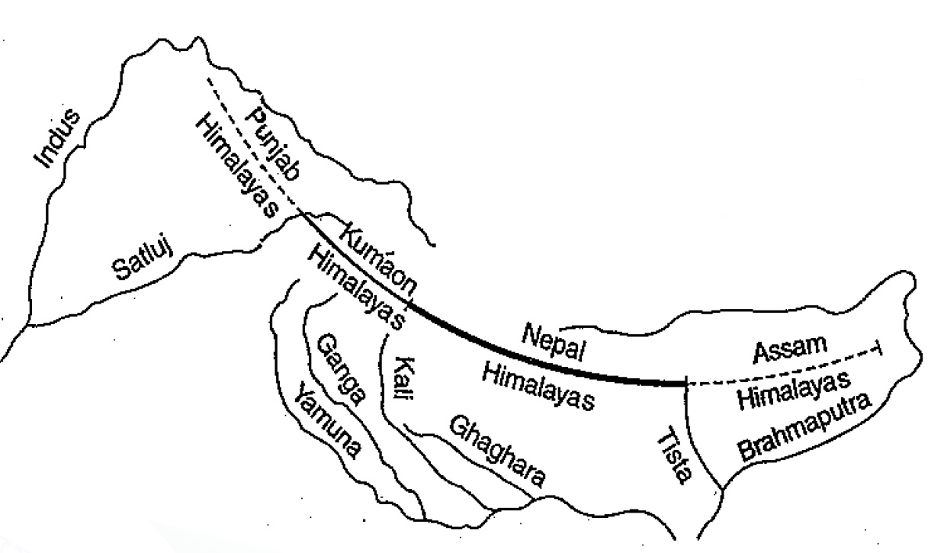

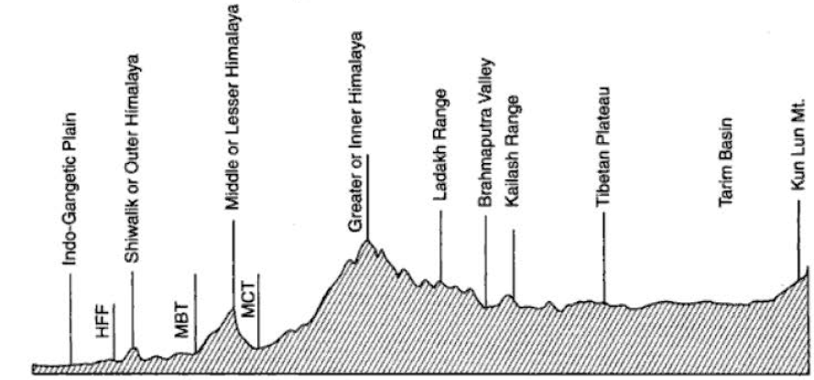2.6 The Himalayan Complex

3. The Great Indian Plains

3.1 Introduction

* Lies to the south of the Himalayas and to the north of the Indian Peninsular region.
* **Arcuate** (Bow shaped) plain known as Indo-Gangetic-Brahmaputra plains
* **Length** of 3200 km
* **Width** varies from 150 km to 300 km.
* Thick layer of alluvium throughout the length and breadth of the plain
* Classic example of aggradational plain.
* According to Oldham, maximum depth of alluvium is 6100 m.
* **Average elevation** about 200 m.
* Highest elevation of 291 m between Saharanpur and Ambala.

3.2. Geomorphology of the plain

3.2.1. The Bhabar

* Narrow belt about 8-16 km wide running in east-west direction along the foot of the Shiwaliks
* It forms the northern boundary of the great plains
* Rivers descending from the Himalayas deposit their load along the foothills in the form of alluvial fans.
* High porosity of the pebble studded rocks causes the streams to flow underground
* Not suitable for agriculture

3.2.2. The Tarai

* 15-30 km wide marshy tract to the south of the Bhabar region
* It runs parallel to the Bhabar region
* It is marked by the re-emergence of the underground streams of the Bhabar belt
* Re-emerged waters convert large areas along the rivers into ill-drained marshy lands
* Covered with thick forests giving shelter to various wildlife
* The Tarai is more marked in the eastern part as it receives more rainfall
* Most of the tarai specially in Punjab, Uttar Pradesh have been reclaimed and turned into agricultural land
* Yields good crops of sugarcane, rice, wheat.

3.2.3. The Bhangar

* **Composed of old alluvium** of the Middle Pleistocene age
* Forms the alluvial terrace above the level of the flood plains.
* Often impregnated with **calcareous concretions** known as ‘Kankar’
* Remnants of the Bhangar are eroded by change in direction of river channels and levelled down by their meandering tendencies
* **‘The Barind plains’** in the deltaic region of Bengal and the **‘Bhur formations’** in the middle Ganga and Yamuna doab are regional variations of Bhangar.
* Contains fossils of animals like rhinoceros, elephant, hippopotamus etc.

3.2.4. The Khadar

* **Composed of newer alluvium**
* **Forms** the **flood plains** along the river banks
* New layer of alluvium deposited by river floods almost every year
* These deposits are confined to the vicinity of the present river channels
* The clays have less ‘Kankar’

3.2.5. The Reh or Kellar

* **Barren saline efflorescence** of drier areas of Uttar Pradesh and Haryana
* Reh areas have spread in recent time due to increase in irrigation

3.2.6. The Bhur

* **Elevated piece of land** situated along the banks of the Ganga river, especially in the Ganga-Yamuna doab.
* This has been **formed due to accumulation of wind-blown sands** during the hot dry months of the year

3.3. Regional Division of the Great Plains – Divided into 4 major regions

* The Rajasthan plain
* The Punjab-Haryana plains
* The Ganga plain
* The Brahmaputra plain

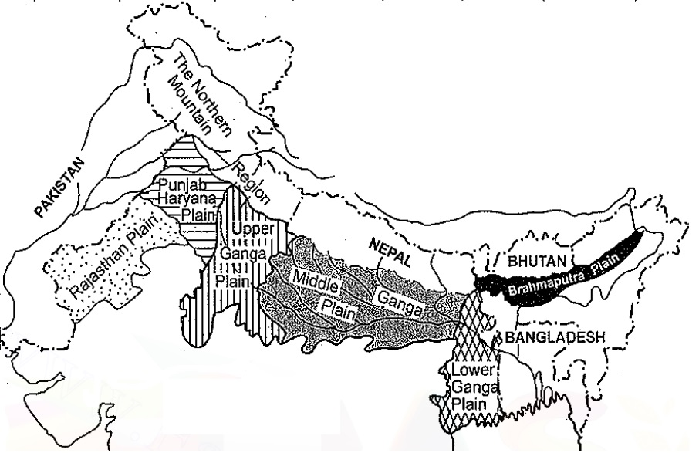

3.3.1 The Rajasthan plains

3.3.1.1. Introduction

* Located in between the Aravalli range and the Sutlej and Indus plains
* Height Gradually diminishes from the Arvallis in the south east (350 m) to the Pakistan plains in the north west (150 m)
* In the lower areas and to the north of Jaisalmer, some salt lakes or Ranns can be seen.
* Lake Sambar is the largest lake of this region

3.3.1.2. Division – Can be divided into 5 sections

3.3.1.2.1. Bagar

* The foot area of the Aravallis i.e. the easternmost region of the Rajasthan plains is known as Bagar
* Almost all the region is covered in grass and some agriculture is seen

3.3.1.2.2. Rohi

* Lies to the immediate west of the Bagar region
* Some rivers have originated from the western slopes of the Aravallis
* These rivers have dried up and have merged into the desert region
* Alluvial deposits on both sides of these rivers, makes the basins fertile
* These fertile lands are known as Rohi

3.3.1.2.3. Little Desert Region

* Located to the immediate west of the Rohi region
* Marks the beginning of the desert

3.3.1.2.4. Stony Region or Hamada

* Lies to the north of the little desert region
* Made up of sandy soft rock deposits

3.3.1.2.5. Sandy Region

* Located to the West of the stony region
* This region is the great Indian Thar desert, which has crossed over into Pakistan
* This region is also known as **Marusthali**
* **Dhrian** – Moving sand dunes
* **Dhand** – Longitudinal lakes in between two parallel sand dunes

3.3.2. The Punjab-Haryana plains

* Desert region gives way to the fertile plains of the Punjab-Haryana.
* Length 640 Km, and 300 Km wide (East-West)
* **Eastern boundary** formed by the **Yamuna river**
* Elevation varies from 300 m in the north to 200 m is the south east
* This plain is formed by the **alluvial deposits of** 5 rivers i.e. **Sutlej, Beas, Ravi, Chenab and Jhelum.**
* It is **primarily made up of doabs** (land between rivers) from east to west these doabs are
  + Bist-Jalandhar doab (Beas and Sutlej)
  + Bari doab (Beas and Ravi)
  + Rachna doab (Ravi and Chenab)
  + Chaj doab (Chenab and Jhelum)
  + Sind sagar doab (Jhelum-Chenab and the Indus)
* The long depositional process of the rivers has united these doabs and given a homogeneous geomorphological identity to the entire area
* Mass of alluvium has been broken by the river courses.
* River courses have carved broad flood plains of khadar **flanked by bluffs** known as **Dhayas**
* These bluffs are as high as 3 m or more are heavily gullied
* The khadar belt known as **Bet lands**, though liable to flooding is agriculturally valuable
* Northern part of the plains bordered by the shiwaliks has been intensively eroded by several streams called **chos.**
* **Chos** are particularly noticeable in the Hoshiarpur district of Punjab.
* Area between Ghaggar and Yamuna river lies the so called **‘Haryana tract’**, which acts as a water divide between Yamuna and the Sutlej rivers
* Only river between Yamuna and the Sutlej is the Ghaggar river, which is considered to be the present-day successor of the legendary **Saraswati** river.

3.3.3. The Ganga Plain

3.3.3.1. Introduction and Subdivision

* Largest unit of the great plain of India covering 3.75 lakh Km2
* The Ganga and its large number of tributaries have brought large amount of alluvium from the mountains and deposited it here to form extensive plains.
* The peninsular rivers which have merged in to Ganga such as Chambal, Betwa, Ken have also contributed in the building of this plain
* The plain can be subdivided into 3 sections
  + The Upper Ganga Plain
  + The Middle Ganga Plain
  + The Lower Ganga Plain

3.3.3.2. The Upper Ganga Plain

* **Yamuna** is its **western border**
* 100m contour line is considered to be its eastern demarcation
* 500 Km long in the east west direction and 380 km wide in north-south direction
* Elevation varies from 100-300 m
* The plain is drained by Ganga and its tributaries i.e. **Yamuna, Ram Ganga, Sarda, Gomati, and Ghaghara** rivers**.**
* Monotony of this flat featureless plain is broken by the tarai-bhabar submonate belt.
* River bluffs, ox-bow lakes, river meanders, abandoned river courses, sandy stretches (Bhurs) are its main features
* Western part of the plain consists of the higher **Ganga-Yamuna doab**
* East of this doab lies the low **Rohilkhand plains** which merge into **Avadh plains** further east
* Ghaghara is the main stream of the Avadh plains

3.3.3.3. The Middle Ganga Plain

* Lies to the east of the Upper Ganga plains
* Occupies the Eastern part of Uttar Pradesh and Bihar
* Eastern boundary of this region is ill-defined
* Very low plain not exceeding 150 m in elevation
* Drained by **Ghaghara, Gandak, Kosi** rivers
* Marked by local prominences like levees, bluffs, oxbow-lakes, marshes, tals, ravines etc.
* ‘Kankar’ formations are less here due to preponderance of Khadar
* Almost all rivers keep shifting their courses, making this region prone to flooding.
* **Kosi** river is called the **‘Sorrow of Bihar’**.
* Several attempts to tame this river has been made by both India and Nepal.
* Major units of this plains are
  + Ganga-Ghaghara doab
  + Ghaghara-Gandak doab
  + Gandak-Kosi doab or **Mithila plain**
* Some rivers join the Ganga from the South as well, **Son** being the most important
* East of Son river lies the **Magadh plain**

3.3.3.4. The Lower Ganga Plain

* Includes the Kishanganj tehsil of Purnea district of Bihar, the whole of West Bengal (except Purulia and mountainous parts of Darjeeling)
* Its length is about 580 Km North-South
* Width of this region varies greatly
* Total area of this plain is about 81 thousand Km2
* Northern part of this plain is formed by the sediment deposited by Tista, Jakdhaka, Torsa
* This area is also marked by the Duars (Left side of Tista river) and the Barind plains (Older alluvium tract)
* The delta formation accounts for 2/3rds of this region
* This is the largest delta of the world
* Large part of the coastal delta is covered by thick impenetrable tidal forests. These are called Sundarbans because of the predominance of the Sundari tree.

3.3.4. The Brahmaputra Plain

* This is also known as the Brahmaputra valley or Assam Valley or Assam Plain as most of the Brahmaputra valley is situated in Assam.
* Extends from easternmost end of Assam to the west of Dhubri near Bangladesh border.
* Length of 720 Km and width of 60-100 Km
* Its western boundary is formed by the Indo-Bangladesh border as well as the boundary of the lower Ganga Plain. Its eastern boundary is formed by Purvanchal hills.
* Entire plain cover an area of 56 thousand Km2
* It is an **aggradational plain** built up by the depositional work of the **Brahmaputra and its tributaries.**
* The innumerable tributaries of the Brahmaputra river coming from the north form a number of **alluvial fans**.
* The tributaries branch out in many channels giving birth to river meandering leading to formation of bill and ox-bow lakes.
* There are **large marshy tracts** in this area. The alluvial fans formed by the coarse alluvial debris have led to the formation of **terai** or **semi-terai** conditions.

4. The Peninsular Plateau

4.1. Introduction

* Roughly triangular in shape, it is the largest physiographic division, covering an area of 16 lakh Km2
* The average height of the plateau is 600-900 m above sea level (varies from region to region). ­
* The Peninsular Plateau is one of the oldest landforms on earth.
* It is a highly stable block composed mostly of the Archaean gneisses and schists

4.2. Division of the Peninsular plateau – The peninsular plateau can be roughly divided into 3 parts

* Central Highlands
* Eastern Highlands
* Deccan Plateau/Southern Highlands

4.2.1. Central Highlands

* Consists of Aravalli and Vindhya ranges
* Malwa, Bundelkhand plateau and Narmada valley

4.2.1.1. The Aravalli Range

* They are aligned in north-east to south-west direction, and run for about 800 km between Delhi and Palanpur in Gujarat.
* They are one of the oldest (very old) fold mountains of the world and the oldest in India.
* The range is conspicuous in Rajasthan (continuous range south of Ajmer 900m)
* Becomes less distinct in Haryana and Delhi (characterized by a chain of detached and discontinuous ridges beyond Ajmer)
* Its general elevation is only 400-600 m, with few hills well above 1,000 m.
* Notable peaks are Mt.Abu (1158 m) and Guru Shikhar (1722 m, highest peak)
* Mt.Abu is separated from the main range by the valley of the Banas
* **Goranghat pass** lies south of Mt. Abu, it joins Udaipur with Sirohi and Jalore
* **Haldighat pass** located 40 Km from Udaipur joins Rajasmand and Pali districts
* Pipli ghat, Dewair and Desuri passes allow movement by roads and railways.

4.2.1.2. The Malwa Plateau

* Bounded by Aravalli to the North West, Bundelkhand plateau to the East and Vindhya to the South.
* This plateau has two systems of drainage
  + Towards Arabian Sea → Narmada, Tapi and Mahi
  + Towards Bay of Bengal → Chambal and Betwa (joining Yamuna)
* It is composed of extensive lava flow and is covered with black soils.
* This is a rolling plateau dissected by rivers. In the north, the plateau is marked by the Chambal ravines.

4.2.1.3. The Bundelkhand Plateau

* Bounded by Yamuna river in the North, Vindhya in the South, and Malwa plateau to the West.
* It is the old dissected (divided by a number of deep valleys) upland of the ‘Bundelkhand gneiss’ comprising of granite and gneiss.
* Spreads over five districts of Uttar Pradesh and four districts of Madhya Pradesh.
* Average elevation of 300-600 m above sea level, this area slopes down from the Vindhyan Scarp toward the Yamuna River.
* Streams like **Betwa, Dhasan** and **Ken** flow through the plateau
* The erosional work of the rivers flowing here have converted it into an undulating (wave like surface) area and rendered it unfit for cultivation.

4.2.1.4. The Vindhya Range

* It runs more or less parallel to the Narmada Valley in an east-west direction from Jobat in Gujarat to Sasaram in Bihar for a distance of over 1,200 km.
* The rivers Chambal, Betwa and Ken rise within 30 km of the Narmada
* The general elevation of the Vindhyan Range is 300 to 650 m.
* Most parts of the Vindhyan Range are composed of horizontally bedded sedimentary rocks of ancient age.
* The Vindhyas are continued eastwards as the **Bharner** and **Kaimur** hills
* This range acts as a watershed between the Ganga system and the river systems of south India.
* **Sadbhawna Shikhar/Kalumar Peak** is the higheat peak of the Vindhyas, only 750 m

4.2.1.5. The Narmada Valley

* Situated to the south of the Vindhya range
* Created due to parallel fault lines
* Denotes the boundary of the central highlands

4.2.2. The Southern Highlands

* Consists of Several Hill/Mountain ranges
  + Satpura, Mahadeo, Maikal
  + Nilgiris
  + Eastern and Western Ghats
* Several Plateaus including
  + Maharashtra plateau
  + Karnataka plateau
  + Telangana plateau

4.2.2.1. Satpura Mahadeo and Maikal Hills

* Satpura range is a series of seven mountains (‘Sat’ = seven and ‘pura’ = mountains)
* It runs in an east-west direction south of the Vindhyas and in between the Narmada and the Tapi, roughly parallel to these rivers.
* It stretches for a distance of about 900 km.
* Dhupgarh (1,350 m) near Pachmarhi on Mahadeo Hills is the highest peak.
* Maikal Range forms a link between the Vindhyas and the Satpuras
* Amarkantak (1,127 m) is another important peak.

4.2.2.2. Eastern Ghats or Malayadri

* Discontinuous mountain range along the east coast of India
* It is a chain of highly broken and detached hills starting from the Mahanadi in Odisha to the Vagai in Tamil Nadu.
* They almost disappear between the Godavari and the Krishna.
* In the northern part between Mahanadi and Godavari it shows true mountain character
* This part comprises the **Maliya** and the **Madugula Konda** ranges.
* Mahendra Giri (1501 m) is the highest peak of the Maliya range
* The Madugula Konda range has higher elevations ranging from 1,100 m and 1,400 m with several peaks exceeding 1,600 m. Jindhagada Peak (1690 m) in Araku Valley Arma Konda (1,680 m), Gali Konda (1,643 m) and Sinkram Gutta (1,620 m) are important peaks.
* The Eastern Ghats reappear as more or less a continuous hill range in Cuddapah and Kurnool districts of Andhra Pradesh where they are called as **Nallamalai Range** with general elevation of 600-850 m.
* Southern part of this range is called **Palkonda** range
* To the south the hills and plateaus attain very low altitudes, Only **Javadi Hills** and **Shevaroy-Kalyaran Hills** attain 1000 m altitude
* The **Biligiri Rangan Hills (BR hills)** in Karnataka (at its border with Tamil Nadu) attain a height of 1,279 m.

4.2.2.3. The Western Ghats or Sahyadris

* Run from the Tapi valley (21° N latitude) to a little north of Kanyakumari (11° N latitude) for a distance of 1,600 km.
* The hills present a stepped topography facing the Arabian Sea coast.
* The Western Ghats abruptly rise as a sheer wall to an average elevation of 1,000 m from the Western Coastal Plain.
* But they slope gently on their eastern flank and hardly appear to be a mountain when viewed from the Deccan tableland.
* South of Malabar, the Nilgiris, Anamalai, etc. present quite different landscape due to the difference in geological structure.

The North Sahayadris

* The northern section of the Ghats from Tapi valley to a little north of Goa is made of horizontal sheets of Deccan lavas (Deccan Traps).
* Kalasubai (1,646 m), Salher (1,567 m), Mahabaleshwar (1,438 m) and Harishchandragarh (1,424 m) are important peaks
* Thal ghat(Mumbai with Nasik) and Bhor ghat(Mumbai with Pune) are important passes which provide passage by road and rail between the Konkan Plains in the west and the Deccan Plateau in the east.

The Middle Sahayadris

* The Middle Sahyadri runs from 16°N latitude upto Nilgiri hills.
* This part is made of granites and gneisses.
* This area is covered with dense forests
* Vavul Mala (2,339 m), Kudremukh (1,892 m) and Pushpagiri (1,714 m) are important peaks.
* The Nilgiri Hills which join the Sahyadris near the trijunction of Karnataka, Kerala and Tamil Nadu, rise abruptly to over 2,000 m.
* Nilgiri so named because of the blue Kurinji blossoms
* Doda Betta (2,637 m) and Makurti (2,554 m) are important peaks of this area.

The Southern Sahayadris

* The southern part of the Western Ghats is separated from the main Sahyadri range by Pal ghat Gap (Palakkad Gap).
* South of the Pal ghat Gap there is an intricate system of steep and rugged slopes on both the eastern and western sides of the Ghats.
* Anai Mudi (2,695 m) is the highest peak in the whole of southern India.
* Three ranges radiate in different directions from Anai Mudi.
  + Anaimalai (1800-2000 m) to the North
  + Palani (900-1,200 m) to the North-East
  + Cardamom Hills or the Ealaimalai to the South.

4.2.2.4. The Maharashtra Plateau

* The Maharashtra Plateau lies in Maharashtra.
* It forms the northern part of the Deccan Plateau.
* Much of the region is underlain by basaltic rocks of lava origin (Most of the Deccan Traps lies in this region).
* The area looks like a rolling plain due to weathering.
* The horizontal lava sheets have led to the formation of typical Deccan Trap topography (step like).
* The entire area is covered by black cotton soil known as regur.

4.2.2.5. The Karnataka Plateau

* The Karnataka Plateau is also known as the Mysore plateau.
* Lies to the south of the Maharashtra plateau.
* The area looks like a rolling plateau with an average elevation of 600-900 m.
* It is highly dissected by numerous rivers rising from the Western Ghats.
* The highest peak (1913 m) is at Mulangiri in Baba Budan Hills in Chikmaglur district.
* The plateau is divided into two parts called **Malnad** and **Maidan**.
* The Malnad in Kannada means hill country. It is dissected into deep valleys covered with dense forests.
* The Maidan on the other hand is formed of rolling plain with low granite hills.
* The plateau tapers between the Western Ghats and the Eastern Ghats in the south and merges with the Niligiri hills there.

4.2.2.6. Telengana Plateau

* The Telangana plateau consists of Archaean gneisses.
* Its average elevation is 500-600 m.
* The southern part is higher than its northern counterpart.
* The region is drained by three river systems, the Godavari, the Krishna and the Penneru.
* The entire plateau is divided into Ghats and the Peneplains (a vast featureless, undulating plain which the last stage of deposition process).

4.2.3. The Eastern Highlands

* Consists of Several plateaus
  + Chotanagpur plateau
  + Baghelkhand Plateau
  + Chattisgarh plains
  + Meghalaya plateau
  + Garhjat hills
  + Dandakaranya

4.2.3.1. Baghelkhand Plateau

* North of the Maikal Range is the Baghelkhand.
* Made of limestones and sandstones on the west and granite in the east.
* It is bounded by the Son river to the north.
* The central part of the plateau acts as a water divide between the Son drainage system in the north and the Mahanadi river system in the south.
* The region is uneven with general elevation varying from 150 m to 1,200 m.
* The Bhanrer and Kaimur are located close to the trough-axis.

4.2.3.2. Chotanagpur Plateau

* Chotanagpur plateau represents the north-eastern projection of the Indian Peninsula.
* Mostly in Jharkhand, northern part of Chhatisgarh and Purulia district of West Bengal.
* The Son river flows in the north-west of the plateau and joins the Ganga.
* The average elevation of the plateau is 700 m above sea level.
* Rivers like the Damodar, the Subarnrekaha, the North Koel, the South Koel and the Barakar have developed extensive drainage basins.
* North of the Damodar river is the **Hazaribagh plateau** with an average elevation of 600 m above mean sea level. This plateau has isolated hills. It looks like a peneplain due to large scale erosion.
* The Ranchi Plateau to the south of the **Damodar Valley** rises to about 600 m above mean sea level. Most of the surface is rolling where the city of Ranchi (661 m) is located.
* The Rajmahal Hills forming the north eastern edge of the Chotanagpur Plateau are mostly made of basalt and are covered by lava flows

4.2.3.3. Garhjat Hills

* Known as Odisha highlands
* Bordered by Chotanagpur plateau in North, Mahanadi basin in the West
* Mainly composed of Archean rocks

4.2.3.4. Dandakaranya

* It is an undulating plateau
* Sprawls over parts of Odisha, Chattisgarh, Andhra Pradesh
* Its Abujhmar hills provide one of the richest iron ore deposits in the Bailadila range
* Drained by Tel and Udanti tributaries of Godavari

4.2.3.5. Meghalaya Plateau

* The peninsular plateau extends further east beyond the Rajmahal hills to from Meghalaya or the Shillong plateau.
* Garo-Rajmahal Gap separates this plateau from the main block.
* The plateau is formed by Archaean quartzites, shales and schists.
* The plateau slopes down to Brahmaputra valley in the north and the Surma and Meghna valleys in the south.
* Its western boundary more or less coincides with the Bangladesh border.
* The western, central and the eastern parts of the plateau are known as the Garo Hills (900 m), the Khasi-Jaintia Hills (1,500 m) and the Mikir Hills (700 m).
* Shillong (1,961 m) is the highest point of the plateau.

4.2.3.6. Chattisgarh Plain

* It is a saucer shaped depression drained by the upper Mahanadi.
* The whole basin lies between the Maikala Range and the Odisha hills.
* The region was once ruled by Haithaivanshi Rajputs from whose thirty-six forts (Chhattisgarh) it derives its name.
* The basin is laid with nearly horizontal beds of limestone and shales
* The general elevation of the plain ranges from 250 m in the east to 330 m in the west.

5. The Coastal Plains

5.1. Introduction

* India has a coastline of 7516.6 Km (Including the Indian Islands)
* As such the coast of India does not offer many sites for good natural harbors.
* The Bay of Bengal and the Arabian Sea came into being during the Cretaceous or early Tertiary period after the disintegration of Gondwanaland.
* The east coast of India, especially its south-eastern part (Tamil Nadu coast), appears to be a coast of emergence.
* The west coast of India, on the other hand, is both emergent and submergent.
* The northern portion of the coast is submerged as a result of faulting and the southern portion, that is the Kerala coast, is an example of an emergent coast.

5.2. The West Coast of India

5.2.1. Kutch and Kathiawar Peninsula

* Kutch and Kathiawar, are an extension of Peninsular plateau.
* Salt-soaked plain to the north of Kutch is the Great Rann. Its southern continuation, known as the Little Rann lies on the coast and south-east of Kachchh.
* The Kathiawar Peninsula lies to the south of the Kachchh.
* The central part is a highland of Mandav Hills from which small streams radiate in all directions
* Mt. Girnar (1,117 m) is the highest point and is of volcanic origin.
* The Gir Range is located in the southern part of the Kathiawar peninsula.

5.2.2. The Gujarat Plains

* The Gujarat Plain lies east of Kachchh and Kathiawar and slopes towards the west and south west.
* Formed by the rivers Narmada, Tapi, Mahi and Sabarmati, the plain includes the southern part of Gujarat and the coastal areas of the Gulf of Khambhat.
* The eastern part of this plain is fertile enough to support agriculture, but the greater part near the coast is covered by windblown loess (heaps of sand).

5.2.3. The Konkan Plains

* The Konkan Plain south of the Gujarat plain extends from Daman to Goa (50 to 80 km wide).
* It has some features of marine erosion including cliffs, shoals, reefs and islands in the Arabian Sea.
* The Thane creek around Mumbai is an important embayment (a recess in a coastline forming a bay) which provides an excellent natural harbor

5.2.4. The Karnataka Coastal Plains

* Extends from Goa to Mangalore.
* It is a narrow plain with an average width of 30-50 km, the maximum being 70 km near Mangalore.
* At some places the streams originating in the Western Ghats descend along steep slopes and make waterfalls.
* The Sharavati while descending over such a steep slope makes an impressive waterfall known as Gersoppa (Jog) Falls which is 271 m high.

5.2.5. The Kerala/Malabar Coast

* Extends from Mangalore and Kanyakumari.
* This is much wider than the Karnataka plain. It is a low lying plain.
* The existence of lakes, lagoons, backwaters, spits, etc. is a significant characteristic of the Kerala coast.
* The backwaters, locally known as kayals are the shallow lagoons or inlets of the sea, lying parallel to the coastline.
* The largest among these is the Vembanad Lake which is about 75 km long and 5-10 km wide and gives rise to a 55 km long spit

.